4th Degree Tresner
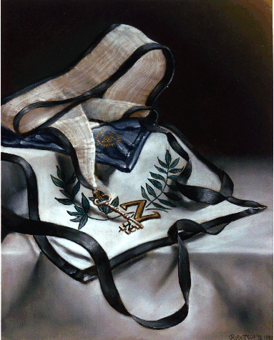Fourth Degree: Secret Master,
Laurel and Olive
Jim Tresner, 33°, Grand Cross
PO Box 70, Guthrie, Oklahoma 73044–0070
Photo: Original oil painting by Bro. Robert H. White, 32°
Black and white. That's the fist thing that strikes the eye in the apron and cordon of the Fourth Degree. Its creation of harmony by the balance of opposites is the first statement of the great theme of the Scottish Rite-the essential philosophical and moral lesson of equilibrium.
White is the color of purity and light; black is the color of mourning and death. And the Rite tells us that we should never forget we are always in the midst of death, that we should never postpone making amends, never leave disputes unresolved, never fail to do a kindness. But neither should we be morbid and focused on death. Death borders what we know of life, but life is still good and filled with joy. The fact that life is transitory makes it all the more precious to us.
Again, the secret is equilibrium. Life is precious, but it must never be so precious that a Scottish Rite Mason accepts dishonor, or loss of integrity, or the sacrifice of others as an acceptable price of living. To shrink from death is natural, but we must never let that natural impulse make us fearful or cowardly.
The blue of the apron's flap represents the heavens, and the eye in the sunburst represents not only the eye of Deity, Who sees and knows all things, but also the sun, the source of visible light and the provider of physical energy to the earth.
Heaven represents the goal of every Mason, and the eye of Deity reminds us that everything we do, even in our most unguarded and frustrated moments, is done in the immediate presence of God, even as its second meaning, that of the sun, reminds us of the warmth and love of God, which so many ancient cultures have typified by the physical light of our star.
The wreath is made of olive and of laurel, symbols of peace and of victory. The victory, as always in the Scottish Rite, is not victory over others, but victory over ourselves-for that is the only victory which brings peace as its reward.
But secrecy must be understood in its Masonic sense. It is not the secrecy of conspiracy, the concealment of motives and activities, or "deeds done in darkness." For a Mason, secrecy is the ability to keep a confidence. Great systems of philosophy have taught through the ages that such ability is the first step in developing self-discipline and self-control.
And there is more. The greatest need in the lives of most people is for a friend in whom they can confide with no fear that what they say will be repeated. Each Scottish Rite Mason should strive to be such a friend.
The second great lesson of the Fourth Degree is duty. Nowadays, many people think of duty as doing the minimum required in a situation. But duty, for a Scottish Rite Mason, is a positive virtue, not a negative requirement. It is a joy to be fulfilled eagerly, not a task to be performed grudgingly.
Duty and secrecy are the foundations not only of the Scottish Rite but of creative living. A man or woman who can be relied upon to do what is right and to respect the confidentiality of a friend's private hopes and fears and doubts and dreams is well down the path of becoming an honored and honorable human being.
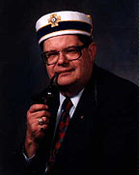 | Jim Tresner  is Director of the Masonic Leadership Institute and Editor of The Oklahoma Mason. A frequent contributor to the Scottish Rite Journal and its book review editor, Illustrious Brother Tresner is also a volunteer writer for The Oklahoma Scottish Rite Mason and a video script consultant for the National Masonic Renewal Committee. He is the Director of the Thirty-third Degree Conferral Team and Director of Work at the Guthrie Scottish Rite Temple in Guthrie, Oklahoma, as well as a life member of the Scottish Rite Research Society, author of the popular anecdotal biography Albert Pike, The Man Beyond the Monument, and a member of the steering committee of the Masonic Information Center. Ill. Tresner was awarded the Grand Cross, the Scottish Rite's highest honor, during the Supreme Council's October 1997 Biennial Session.
Scottish Rite Regalia Photos And Prints
Illustrations of the Scottish Rite regalia paintings by Brother Robert H. White, 32°, (Fourth Degree, Secret Master, painting pictured above) are available in two formats:
(1) individual 8" x 12" or 11" x 14" color photographs and
(2) grouped photos in a color 22" x 33" poster.
To order individual photographs, please contact Brother Bruce A. Dehlin, K.D. Enterprises, 10114 Farmington Drive, Fairfax, VA 22030–2049. Credit cards accepted. Tel. (703) 591-5318; Fax: (703) 591-6026; E-mail: dehlinb@cais.net
To order color posters picturing all the regalia paintings, Fourth through Thirty-third Degrees, including the K.C.C.H. and Grand Cross, use VISA or MasterCard or send a check (domestic only) for $20.00 payable to The Supreme Council, 33°, S.J., USA to:
Grand Executive Director's Office
1733 16th Street, NW
Washington, DC 20009–3103

Return to our Lodge of Perfection Page

